 | COEP Technological University, Pune  A Unitary Public University of Government of Maharashtra  Department of Applied Sciences & Humanities  (School of Transdisciplinary Sciences & Management)  Wellesley Road, Chhatrapati Shivajinagar, Pune - 411005. | 

Biology for Engineers – Classnotes
-------------------------------------------------------------------------------------------------------------------------------
Unit III: Analogy of biological organ/system and engineering device/mechanism

Organ & System: Brain & CPU, Eye & Camera, Kidney & Filtration system, Lungs & purification system, Heart & Pumping system
Process: Photosynthesis & solar cells, xylem & plumbing, thermoregulation in human body & heat transfer in machine, Defense mechanism in organism, Electrical signaling in biology
-------------------------------------------------------------------------------------------------------------------------------

EYE and CAMERA

Human eye is one of the most powerful and sophisticated sense organs. It assists in viewing objects as well as enables us to perceive light, color, and depth. In terms of its functioning, it is comparable to cameras. Cameras help humans see things when light from outside enters them. The structure and operation of the human eye also aid in our comprehension of how a camera works. Our eyes can gaze around and adjust dynamically based on the environment. Hence, we might think there is no difference between the human eye and a camera. The camera sees whatever the eyes can see, so how exactly are they different from each other? Things, however, are not as simple as they seem; they are way more complicated.

Human Eye: A human eye has a 2.3 cm diameter and is a spherical-shaped ball filled with fluid. It is made up of the following components:
- Sclera: The sclera is the outer covering, a solid white layer that protects the skin (white part of the eye).
- Cornea: The cornea is the front transparent section of the sclera. Light can enter the eye through the cornea.
- Iris: The iris is a black muscular tissue with a ring-like structure behind the cornea.
- Pupil: A pupil is a tiny aperture in the iris.
- Lens: A lens is a translucent structure located behind the pupil. It changes form due to the action of ciliary muscles to focus light on the retina.
- Retina: A light-sensitive layer made up of many nerve cells. It converts the lens's pictures into electrical impulses.
- Optic nerves are classified into two categories: cones and rods.
  - Cones: Cones are nerve cells that are exceptionally responsive to intense light. They aid with fine-grained central and color vision.
  - Rods: Rods are the optic nerve cells that are particularly sensitive to low-light conditions.
- Blind Spot: The area where there are no sensory nerve cells at the interjunction of the optic nerve and the retina is known as a blind spot.

A camera is an optical equipment that collects visual images. At its most basic, cameras are sealed boxes (the camera body) with a small hole known as the aperture that allows light to pass through and capture a picture on a light-sensitive surface. Cameras use various methods to manipulate how light falls on a light-sensitive surface. Lenses focus the light that enters the camera, and the aperture size can be enlarged or constricted. A shutter mechanism controls how long the photosensitive surface is exposed to light. In the art of photography, the still image camera is the primary tool. Captured images can be reproduced later as part of the photography, digital imaging, or photographic printing processes. Film, cinematography, videography are similar artistic professions in the moving-picture camera realm.

Mechanism:
Cameras catch light photons, often from the visible spectrum. Still, they can also capture photons from other parts of the electromagnetic spectrum. Light enters an enclosed box by a converging or convex lens. An image is captured on a light-sensitive medium in all cameras. The amount of time light enters the camera is controlled by a shutter mechanism. Most cameras also have a viewfinder. A viewfinder is used to display the scene that is to be captured and it lets you manage the focus and exposure.

Similarities between Human Eye and Camera
Eyes and the camera do have some things in common such as:
- Cornea functions similarly to the front lens element of a lens. They are the focusing elements of the eye, together with the lens, which is located behind the iris. The cornea widely bends which in turn diverges the rays of light via the pupil, the circular aperture in the center of the colored iris.
- Iris and pupil function similarly to the aperture of a camera. The iris is a muscle that, when contracted, covers all but a small central section of the lens, allowing for changeable control of the amount of light entering the eye, allowing the eye to function correctly in a wide variety of viewing circumstances, from dim to extreme light.
- The sensory layer that lines the very back of eyes is known as the retina. It functions similarly to the imaging sensor chip in a digital camera. The retina contains a large number of photoreceptor nerve cells, which convert light rays into electrical impulses and convey them through the optic nerve to the brain, where an image (of what we see) is finally received and perceived.
- The retina is likely the most significant component of our eyes because of its reception and perception function. If the "film" in the eye (i.e. the retina) is faulty, we will not get a decent quality image or picture no matter how good the rest of the eye is.

Eye vs Camera
Although with all these similarities, eye and camera differ from each other as follows:
- An eye is a visual organ, whereas a camera is a piece of technology used to capture or record images.
The first and most obvious distinction between an eye and a camera is that an eye cannot record images. The eyes detect and interpret light using living cells, which are converted into electrical signals that are conveyed to the brain and processed into an image. On the other hand, the camera employs a diaphragm through which the image is captured on film or, in newer cameras, on tape or digitally.
- Eyes are more flexible than cameras.
Tiny muscles in the human eye contract and relax, allowing the eyes to change shape and remain focused on a moving object. These muscles can also change the thickness of the lens to accommodate the image being viewed. A camera cannot do this, and it must rely on a range of lenses. This is why photographers frequently alter the lens of their camera based on the distance from the target. Furthermore, cameras rely on mechanical components to maintain focus on a moving object.
- A camera sees in two dimensions, whereas the eye perceives in three dimensions.
This implies that we notice the height, width, and depth when looking at something. We can only observe height and width with a camera. Because a photograph is a flat medium, there is no way to have depth in the image. This is accomplished chiefly through the eye's stereoscopic vision. Attempting to bring the forefingers of both hands together from the sides is a simple demonstration of this. This is considerably easier to achieve with both eyes open than with just one, and it's nearly impossible with a camera.
- Eyes see through photoreceptors while cameras use photosites.
Photoreceptors are specialized cells found in human eyes. Rods and cones are the two types. Cones are used for color vision, whereas rods are used for low-light vision. Cones are classified into three categories, each responding to a different wavelength of light. Blue cones, for example, respond to short wavelengths, red cones to long wavelengths, and green cones to middle wavelengths. The color we see is caused by the brain activating the cones in different combinations.
Cameras use photosites to gather light. A typical camera contains millions of these light collectors, which collect light and transform it into a signal that electronic systems can read. Furthermore, cameras employ filters that divide light into its fundamental colors – red, blue, and green. By blending these colors, it creates a full-spectrum image.
- Eyes are more adaptable than cameras.
The retina and sections of the pupil adjust in size when the focus changes. The movement of the lens, on the other hand, changes the direction of a camera. The the eye may also adjust to the dark, and in a matter of seconds, one can begin seeing better in the night. However, if a camera is not designed to capture low-light photographs, it will never adapt.
- Eyes have a blind spot while the cameras don’t.
The human eye features a blind spot, which is positioned where the optic nerve meets the retina. Under normal conditions, we are unaware of this blind spot because the brain uses information from the other eye to fill in the missing area of the image. A camera does not have this kind of blind spot.

The differences between the human eye and the camera are as follows:
Human Eye | Camera
Human Eyes are visual organs | The camera is a piece of technology
Eyes are flexible and are filled with fluid. | Cameras are rigid.
Since the lens is flexible, they are moved with the muscle . | Cameras are rigid, so the lens is solid.
Rod and cons are specialized cells that send images to the brain. | There is a simple compound present in the film that retains the images.
Eyes cannot record images | Cameras can record images, videos
Eyes can see in three dimensions | Cameras can see in only two dimensions
The eye can adjust to the dark in a matter of seconds, one can begin seeing better in the night after some time. | However, if a camera is not designed to capture low-light photographs, it will never adapt.
The human eye features a blind spot, which is positioned where the optic nerve meets the retina. | A camera does not have this kind of blind spot.

Things to Remember
- An eye is a visual organ, whereas a camera is a piece of technology used to capture images.
- An eye cannot record images; a camera can.
- Tiny muscles in the human eye contract and relax, allowing the eyes to change shape and remain focused on a moving object.
- A camera sees in two dimensions, whereas the eye perceives in three.
- Photoreceptors are specialized cells found in human eyes. Rods and cones are the two types. Cones are used for color vision, whereas rods are used for low-light vision.
- Cameras use photosites to gather light.
- The eye possesses a blind spot, often known as scotoma, but cameras have no such limits.
- Our Cornea functions similarly to the front lens element of a lens.
- Our iris and pupil function similarly to the aperture of a camera
- The retina functions similarly to the imaging sensor chip in a digital camera.

Source: https://collegedunia.com/exams/difference-between-human-eye-and-camera-definition-and-similarities-biology-articleid-5804#c3

The camera and the human eye have much more in common than just conceptual philosophy — the eye captures images similar to the way the camera does. The anatomy of the camera bears more similarities to a biological eyeball than many would imagine, including the lens-like cornea and the film-like retina. Similarities like these give the camera the appearance of a robotic eye. However, though there are many similarities between cameras and eyes, they are by no means identical.
Cornea and Lens
The cornea is the “cap” of the eye. This transparent (like clear jelly) structure sits to the front of the eye and has a spherical curvature. The lens of a camera is also transparent (glass) and sits at the front of the body. Like the cornea, the lens also maintains a spherical curvature. The corneal and lens curvature allows for the eye and camera to view, though not in focus, a limited area to both the right and the left. That is, without the curve, the eye and camera would see only what is directly in front of it.
Iris and Aperture
The aperture is to the camera as the iris is to the eye, and this reveals one of many similarities between cameras vs. eyes. The aperture size refers to how much light is let into the camera and will ultimately hit the sensor or film. As with the human eye, when the iris contracts itself, the pupil becomes smaller and the eye takes in less light. When the iris widens in darker situations, the pupil becomes larger, so it can take in more light. The same effect happens with the aperture; larger (lower) aperture values let in more light than a small (higher) aperture value. The lens opening is the pupil; the smaller the opening, the less light let in.
Focus in Eyes and Cameras
Both the eye and camera have the ability to focus on one single object and blur the rest, whether in the foreground (shallow depth of field) or off at a distance. Likewise, the eye can focus on a larger image, just as a camera (greater depth of field) can focus and capture a large scape.
Scope and Field of View
As the eye, the camera has a limited scope to take in what is around it. The curvature of the eye and the lens allow for both to take in what is not directly in front of it. However, the eye can only take in a fixed scope, while a camera’s scope can be changed by the focal length of different types of lenses.
Retina and Film
The retina sits at the back of the eye and collects the light reflected from the surrounding environment to form the image. The same task in the camera is performed either by film or sensors in digital cameras. This process underpins both how cameras work and how eyes work.

Researchers develop efficient solar cell technology by mimicking plants' photosynthesis process By Park Sae-jin

By inducing an ideal electron flow process called vectorial transfer, South Korean researchers were able to develop a solar cell manufacturing technique that can produce cells with up to 60 percent more electron transfer efficiency than conventional cells. The new technique allows photovoltaic cells to control electron flow in one desired direction to reduce the loss of electrons during power generation.
Conventional photosensitizers used in photovoltaic cells have strong electronic coupling characteristics which lose a lot of electrons when transferred between molecules because of the rapid recombination of electrons and electron holes. Electron holes are positions that lack an electron in an atom or atomic lattice. Natural photosystems, such as those used by plants for photosynthesis, utilize vectorial transfer to control the direction of electron flow and prevent the recombination of electrons and holes. Plants show about 100 percent efficiency in the transfer of electrons.
The Ulsan National Institute of Science and Technology (UNIST) said in a statement that a joint team involving researchers from UNIST and Japan's Shinshu University developed a technique to create more efficient solar cells using a specially designed dye that has both strong and weak electronic coupling characteristics to minimize the electron recombination phenomenon.
Solar cells using the dye showed a maximum photovoltaic efficiency of 10.8 percent, which is about 60 percent more efficient than conventional cells. The rate of recombination was about 12.5 percent compared to ordinary photovoltaic cells. "The molecular design strategy developed in this study can be applied not only to solar cells but also to various fields such as artificial photosynthesis and photocatalysts," UNIST researcher Kwon Tae-hyuk was quoted as saying.

THERMOREGULATION

Thermoregulation is the process by which animals maintain a stable body temperature despite changes in their environment. Animals use a combination of physiological and behavioral strategies to control their heat balance. Some ways animals regulate their body temperature:
Exothermy
Animals rely on external heat sources. Cold-blooded animals, also known as poikilotherms, use this strategy to regulate their temperature by moving to different areas to take advantage of the environmental temperature.

Endothermy
Animals rely on internally generated heat. Warm-blooded animals, also known as homeotherms, use this strategy, along with other internal physiological mechanisms, to regulate their body temperature.

Shivering
Skeletal muscles contract to produce heat.

Sweating
Brown adipose tissue (BAT) is catabolized to produce sweat, which helps cool the skin and conserve core body temperature. However, sweating can also lead to dehydration and electrolyte depletion.

Panting
An effective cooling mechanism, but it also increases metabolic rate and heat production.

Torpor
Nocturnal animals like skunks enter a state of decreased body temperature and minimized energy loss from midnight until dawn.

Counter-current brain coolers
Some animals use the cool nasal cavity to avoid overheating their brain during intense activity.

Vasoconstriction
Blood vessels under the skin narrow to decrease blood flow and retain heat.

Thermogenesis
Organs produce heat to keep the body warm.

Hormonal thermogenesis
The thyroid gland releases hormones to increase metabolism and produce more heat.

The hypothalamus controls the mechanisms of thermoregulation. When body temperature varies, the hypothalamus sends signals to cells, muscles, and other systems to help regulate body temperature.

Temperature is a Major Factor Affecting Tissue Function

Because body function is the result of chemical and physical processes that are sensitive to changes in temperature, animals use a variety of strategies to regulate the temperature of their tissues. If body temperature is allowed to decrease too much below its normal value of about 38° C (~100° F), metabolic processes are slowed to such an extent that body functions are severely impaired. Below 34° C (93.2° F), animals become unable to regulate their own temperature, and at 27° to 29° C (80.6° to 84.2° F), cardiac fibrillation and death occur. At the other extreme, an increase in temperature to 45° C (113° F) can cause fatal brain lesions.

Homeotherms and Poikilotherms Use Different Strategies to Regulate Body Temperature
Fish, reptiles, and amphibians are called cold-blooded animals, or poikilotherms, because their body temperature varies with the temperature of the environment. However, this does not mean that these animals have no control over their body temperature. They use behavioral methods to prevent major changes in their temperature. For example, the lizard basks on a sun-baked rock to increase its temperature early in the morning and hides beneath the rock later in the day to prevent overheating. Veterinarians are sometimes asked to advise on the management of captive poikilotherms; it is important to remind owners to provide supplemental heat if they want their animals to be active at the cooler times of the year.

Mammals and birds are homeotherms; they maintain a constant body temperature in the presence of considerable changes in environmental temperature. Although the maintenance of a constant temperature allows mammals to live in a wide variety of environments and to remain active during the cold times of the year, it is not without cost. Homeotherms must maintain a high metabolic rate just to provide the heat necessary to maintain body temperature. This requires a high energy intake and therefore almost constant foraging for food. Poikilotherms require much less energy and are better able to survive times of food shortage. Because most veterinarians are primarily concerned with mammals and birds, this chapter focuses on the maintenance of a normal body temperature by homeotherms.

Body Temperature Depends on the Balance Between Heat Input and Heat Output
Heat inputs to the body are from metabolism and from external sources. When food energy is ingested, heat is produced at all stages of the metabolic process. Eventually, all food energy is converted into heat, which is dissipated into the environment and radiated into space. Heat production by the body is related to metabolic rate. A basal metabolic rate is necessary to maintain the function of cells. During exercise, metabolic heat production can increase more than tenfold. If this heat is not dissipated to the environment, body temperature can increase to dangerous levels. Furthermore, this increase in body temperature increases metabolic rate, which further increases heat production.
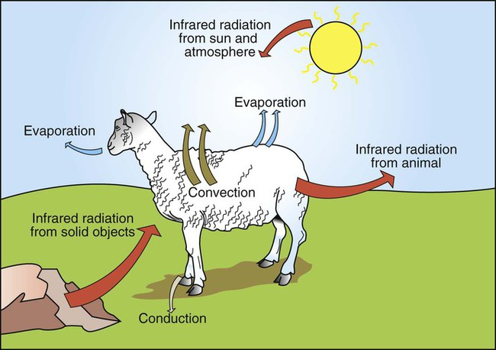 Representation of the heat input and heat output between a mammal and the environment.

Animals gain heat from the environment when ambient temperature exceeds body temperature and when they are exposed to radiant heat sources. The latter occurs when an animal is exposed to sunlight or is placed close to solid objects that are warmer than its body temperature. Heat is lost to the environment by radiation from the body surface to a cooler object; by convection as the surrounding air or water is warmed by the body; by evaporation of respiratory secretions, sweat, or saliva; and by conduction to cooler surfaces with which the animal is in contact. A small amount of heat is also lost with urine and feces.

Many of the metabolic heat sources, such as the liver, heart, and limb muscles, are remote from the skin, which is the site of heat loss. Therefore, it is necessary to transfer heat among these sites. Body tissues are poor conductors, so heat is transferred mainly by convection in the circulation.

Heat Production
Heat Is a Byproduct of All Metabolic Processes
The table shows the amount of heat produced by the metabolism of carbohydrates, fats, and proteins. The basal metabolic rate (BMR) is the rate of energy metabolism measured under minimal stress while the animal is fasting. BMR is greater in homeotherms than in poikilotherms because homeotherms need to generate heat to maintain body temperature. The BMR per kilogram of body weight is greater in smaller than in larger mammals. This is necessitated partly by the greater surface/volume ratio of smaller animals. The relatively greater surface area per kilogram body weight of small animals provides a larger area for heat loss.
Amount of Heat Produced by Metabolism of Major Food Types
Food Type | Heat Production (kcal/g)
Food Type | Per Gram of Food | Per Liter of O₂ Consumed | Per Liter of CO₂ Produced
Carbohydrates | 4.1 | 5.05 | 5.05
Fat | 9.6 | 4.75 | 6.67
Proteins (to urea) | 4.2 | 4.46 | 5.57
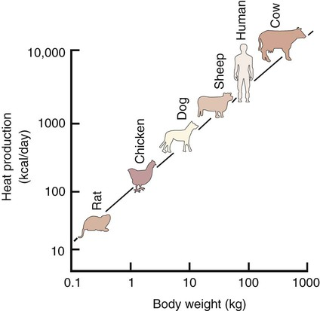

Relationship between body weight and heat production.

Shivering Produces Heat by Muscle Contraction
Shivering is one method of increasing the metabolic production of heat. Antagonistic groups of limb muscles are activated so that they produce no useful work. The chemical energy used in shivering is transferred to the body core as heat. If necessary, shivering can go on for many hours and can double heat production. Short bursts of shivering can even increase heat production up to fourfold.
Nonshivering Thermogenesis Is an Increase in Basal Metabolic Rate, Caused Especially by the Oxidation of Brown Fat, to Produce Heat
When animals are chronically exposed to cold, they develop the ability to increase metabolic heat production without shivering (nonshivering thermogenesis). This increase in metabolism is mediated through an increase in secretion of thyroid hormones and the calorigenic effects of catecholamines on lipids. The table shows that fat metabolism is an effective way to produce heat. Brown fat is a specialized vascular, mitochondria-rich fat that is used to generate heat. It is widely distributed within the body of all mammals but is especially prevalent in small mammals where, combined with white fat it forms both subcutaneous and trunk depots. Cold stress–induced neural release of norepinephrine from the primarily adrenergic nerve supply activates β₃-adrenergic receptors on adipocytes which increases fat metabolism to produce heat that is distributed around the body through the bloodstream. Furthermore, under cold stress white adipocytes can be converted to the brown adipocytes necessary for heat generation.

Heat Transfer in the Body

Because Tissues Are Poor Conductors, Heat Is Most Effectively Transferred in the Blood

Because heat is produced primarily in muscles of the limbs and in the liver and is eliminated through the skin and the respiratory tract, it is necessary to transfer heat around the body. Tissues have poor thermal conductivity; therefore, conduction is not an efficient means of heat redistribution.

The blood perfusing a metabolically active organ collects heat and transfers it to cooler parts of the body by circulatory convection. Redistribution of blood flow can deliver heat preferentially to certain body regions, or it can allow regions to cool when the maintenance of the temperature of the brain and major viscera (core temperature) is threatened.

Under conditions of heat stress, circulatory transfer of heat to the skin can be increased dramatically by two mechanisms. First, the arterioles of skin vascular beds dilate, which results in increased capillary blood flow. Second, arteriovenous anastomoses open in the limbs, ears, and muzzle. These two actions greatly increase the total blood flow to the periphery, and the increased heat delivery increases the temperature of the skin, which facilitates heat loss. Conversely, under cold stress, skin vascular beds vasoconstrict, and arteriovenous anastomoses close; thus skin and limb temperatures decrease. This results in reduced heat loss from the skin and in a gradient of temperatures along the limb. Under severe cold stress, the skin temperature of the extremities can approach ambient temperature. Interestingly, the lipids in the limb extremities have a lower melting point than those in the core, so fats do not solidify in extreme cold stress.

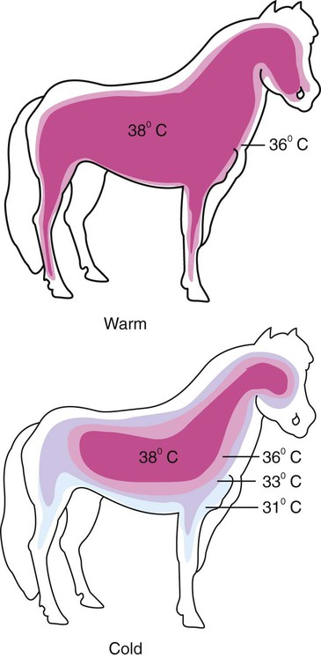

Representation of the distribution of temperatures in a pony under warm and cold environmental conditions. Under warm conditions, the core body temperature extends into the limbs and close to the skin surface of the animal. Under cold conditions, vasoconstriction in the peripheral blood vessels results in a gradient of temperatures between the core and the extremities. The core temperature is maintained only in the abdomen, thorax, and brain of the animal. The more peripheral tissues are allowed to cool considerably.

Countercurrent Heat Exchange Mechanisms Are Used Both to Conserve and to Lose Heat
When the environmental temperature is high, the blood perfusing the skin vascular beds returns to the body core through superficial veins from which heat is lost to the skin and air. Under cold conditions, limb blood flow returns to the core through deep veins that accompany arteries. Heat is transferred by countercurrent exchange from the warm arterial blood to the cooler venous blood and thereby returned to the core of the body.
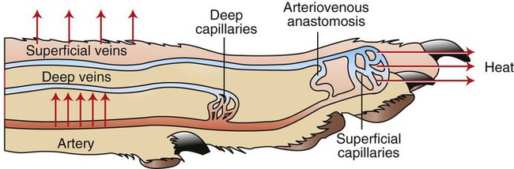 Representation of a limb showing the arterial supply and venous drainage by deep and superficial veins. Under warm conditions, blood perfuses the more superficial capillary beds, and heat is lost to the environment through the skin. Blood returns from these superficial vascular beds through the superficial veins, and this provides an additional source of heat loss. Under cold conditions, peripheral vasoconstriction occurs, and the blood flow to the limb is directed to the deeper vascular beds and returns to the trunk through the deep veins. Countercurrent heat exchange between the arteries and veins conserves body heat.

A similar countercurrent exchange of heat occurs in a carotid rete in sheep and some other ungulates. In this system the carotid artery forms a rete bathed in a sinus of venous blood that has drained the nasal cavity. The colder venous blood from the nose cools the arterial blood supplying the brain and protects the temperature of the brain. This mechanism becomes important during exercise, when the increase in ventilation aids in cooling the blood that drains from the nose. As a result, the arterial blood carrying heat from the exercising muscles is cooled before it enters the brain.

Some mammals, including humans and horses, do not possess a carotid rete and must rely on other thermoregulatory mechanisms to cool their brains during exercise. In the horse the guttural pouches may serve as such a mechanism. The guttural pouches contain air that is cooler than the arterial blood carried in the internal carotid artery. Because anatomically these guttural pouches surround the internal carotid arteries, heat is transferred from the blood to the air in the guttural pouches, thus protecting the brain from hyperthermia. In addition, the intracranial cavernous venous sinuses may assist in cooling the horse’s brain during exercise. This mechanism is thought to function in the same manner as the carotid rete, but less efficiently.
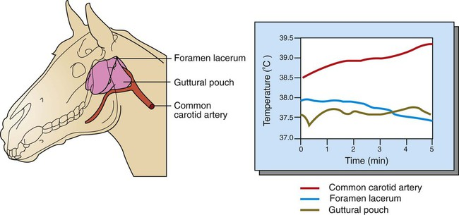 Guttural pouches cool the blood passing through the internal carotid artery on its way to the brain. Left, Anatomic arrangement of the guttural pouches and carotid arteries in the skull. The location of the temperature probes used to measure blood temperature is indicated. Right, Graph of blood and guttural pouch temperatures during a period of cantering. Note that even though the temperature of blood entering the guttural pouch in the common carotid artery increases with the duration of exercise, temperature at the foramen lacerum (where the internal carotid artery enters the cranium) decreases slightly.

Heat transfer mechanisms in machines include heat exchangers, heat sinks, and heat pipes:
Heat exchangers
Transfer heat between fluids or media of different temperatures. Heat exchangers are used in many applications, including refrigeration, air conditioning, and power generation. The three main types of heat exchanger flow are parallel, counter, and cross.
Heat sinks
Transfer heat from solid materials to fluids like air or liquids. Car radiators are an example of a heat sink.
Heat pipes
Transfer heat between solid interfaces by combining thermal conductivity and phase transition.
Heat press machines
Used in the printing industry to apply heat transfers to materials like t-shirts and caps. A heat press machine has a heat platen, a heating element, and upper and lower platens that apply pressure.
In biological systems, the three main mechanisms of heat transfer are conduction, convection, and radiation:

Conduction
Heat is transferred through contact. When molecules touch, the hot molecules cause their neighbors to heat up and vibrate faster.
Convection
Uses the movement of fluids. For example, when water heats up in a pan, the hot water rises to the surface and pushes cold water to the bottom.
Radiation
Transfers heat through electromagnetic waves. Radiation does not require a medium to move through.

Thermoregulation of the Human Body

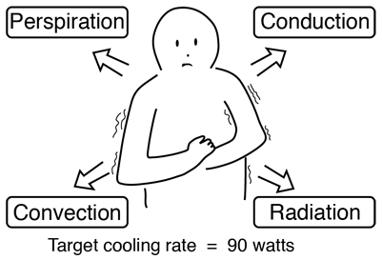 | The human body has the remarkable capacity for regulating its core temperature somewhere between 98°F and 100°F (36.6⁰C to 37.7⁰C) when the ambient temperature is between approximately 68°F and 130°F (20.0⁰C to 54.4⁰C) according to Guyton (This presumes a nude body and dry air).

The external heat transfer mechanisms are radiation, conduction, convection and evaporation of perspiration. The process is far more than the passive operation of these heat transfer mechanisms, however. The body takes a very active role in temperature regulation. The temperature of the body is regulated by neural feedback mechanisms which operate primarily through the hypothalmus. The hypothalmus contains not only the control mechanisms, but also the key temperature sensors. Under control of these mechanisms, sweating begins almost precisely at a skin temperature of 37°C and increases rapidly as the skin temperature rises above this value. The heat production of the body under these conditions remains almost constant as the skin temperature rises.

If the skin temperature drops below 37°C a variety of responses are initiated to conserve the heat in the body and to increase heat production. These include
- Vasoconstriction to decrease the flow of heat to the skin.
- Cessation of sweating.
- Shivering to increase heat production in the muscles.
- Secretion of norepinephrine, epinephrine, and thyroxine to increase heat production
- In lower animals, the erection of the hairs and fur to increase insulation.

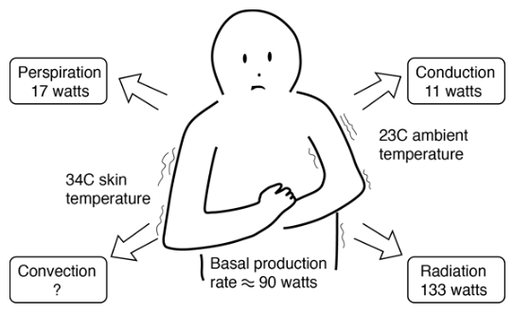
Cooling of the Human Body
This is a simplified model of the process by which the human body gives off heat. Even when inactive, an adult male must lose heat at a rate of about 90 watts as a result of his basal metabolism. One implication of the model is that radiation is the most important heat transfer mechanism at ordinary room temperatures. This model indicates that an unclothed person at rest in a room temperature of 23⁰C or 73 Fahrenheit would be uncomfortably cool. Select one of the cooling mechanisms for further details about how the model numbers were obtained. The skin temperature of 34⁰C is a typical skin temperature taken from physiology texts, compared to the normal core body temperature of 37⁰C.
Even when inactive, an adult male must lose heat at a rate of about 90 watts as a result of his basal metabolism. This becomes a problem when the ambient temperature is above body temperature, because all three standard heat transfer mechanisms work against this heat loss by transferring heat into the body. Our ability to exist in such conditions comes from the efficiency of cooling by the evaporation of perspiration.
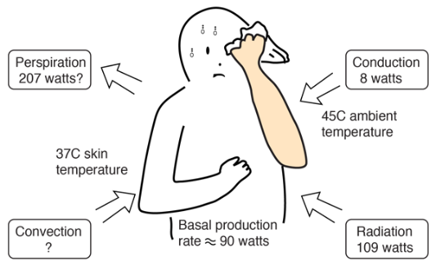
At a temperature of 113 Fahrenheit (45⁰C) the evaporation process must overcome the transfer of heat into the body and give off enough heat to accomplish a 90 watt net outward flowrate of energy. Because of the body's temperature regulatory mechanisms, the skin temperature would be expected to rise to 37°C at which point perspiration is initiated and increases until the evaporation cooling is sufficient to hold the skin at 37°C if possible. With those assumptions about the temperatures, the Stefan-Boltzman law for an area of 2 m² and emissivity 0.97 gives a net input power of 109 watts to the body. The perspiration cooling must overcome that and produce the net outflow of 90 watts for equilibrium.
The transfer of heat is normally from a high temperature object to a lower temperature object. Heat transfer changes the internal energy of both systems involved according to the Ist law of Thermodynamics.
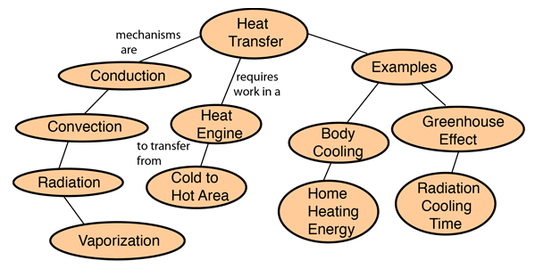

Heat Conduction
Conduction is heat transfer by means of molecular agitation within a material without any motion of the material as a whole. If one end of a metal rod is at a higher temperature, then energy will be transferred down the rod toward the colder end because the higher speed particles will collide with the slower ones with a net transfer of energy to the slower ones. For heat transfer between two plane surfaces, such as heat loss through the wall of a house, the rate of conduction heat transfer is:
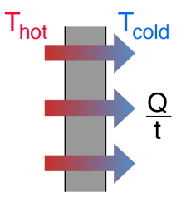
  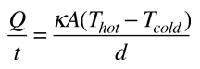
  = heat transferred in time =
  = thermal conductivity of the barrier
   | area
  = temperature
  = thickness of barrier

Stefan-Boltzmann Law
The thermal energy radiated by a blackbody radiator per second per unit area is proportional to the fourth power of the absolute temperature and is given by
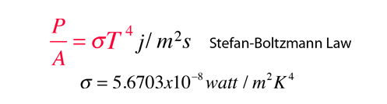
For hot objects other than ideal radiators, the law is expressed in the form:

where e is the emissivity of the object (e = 1 for ideal radiator). If the hot object is radiating energy to its cooler surroundings at temperature T_{c}, the net radiation loss rate takes the form

The Stefan-Boltzmann relationship is also related to the energy density in the radiation in a given volume of space.

Heat Radiation
Thermal radiation is energy transfer by the emission of electromagnetic waves which carry energy away from the emitting object. For ordinary temperatures (less than red hot"), the radiation is in the infrared region of the electromagnetic spectrum. The relationship governing the net radiation from hot objects is called the Stefan-Boltzmann law:
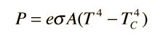
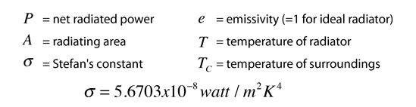
While the typical situation envisioned here is the radiation from a hot object to its cooler surroundings, the Stefan-Boltzmann law is not limited to that case. If the surroundings are at a higher temperature (T_{C} > T) then you will obtain a negative answer, implying net radiative transfer to the object.

Heat Convection
Convection is heat transfer by mass motion of a fluid such as air or water when the heated fluid is caused to move away from the source of heat, carrying energy with it. Convection above a hot surface occurs because hot air expands, becomes less dense, and rises. Hot water is likewise less dense than cold water and rises, causing convection currents which transport energy.
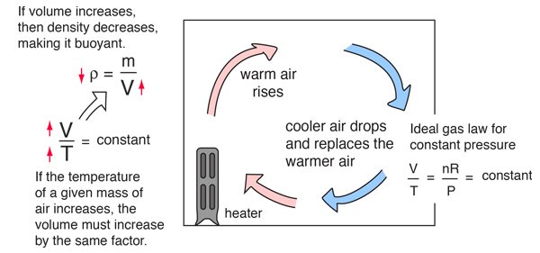
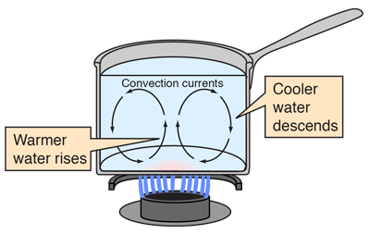 | Convection can also lead to circulation in a liquid, as in the heating of a pot of water over a flame. Heated water expands and becomes more buoyant. Cooler, more dense water near the surface descends and patterns of circulation can be formed, though they will not be as regular as suggested in the drawing.

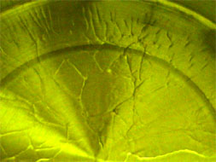 | Convection cells are visible in the heated cooking oil in the pot at left. Heating the oil produces changes in the index of refraction of the oil, making the cell boundaries visible. Circulation patterns form, and presumably the wall-like structures visible are the boundaries between the circulation patterns.

Convection is thought to play a major role in transporting energy from the center of the Sun to the surface, and in movements of the hot magma beneath the surface of the earth. The visible surface of the Sun (the photosphere) has a granular appearance with a typical dimension of a granule being 1000 kilometers. The image at right is from the NASA Solar Physics website and is credited to G. Scharmer and the Swedish Vacuum Solar Telescope. The granules are described as convection cells which transport heat from the interior of the Sun to the surface. | 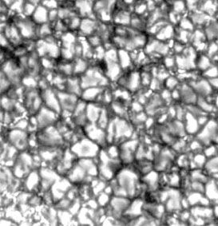
In ordinary heat transfer on the Earth, it is difficult to quantify the effects of convection since it inherently depends upon small nonuniformities in an otherwise fairly homogeneous medium. In modeling things like the cooling of the human body, we usually just lump it in with conduction.

Perspiration Cooling of Body
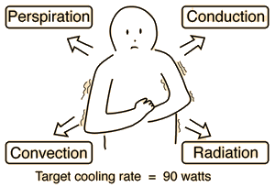  For 600 gm/day perspiration,  cooling rate Q/t = 17 watts. | When the ambient temperature is above body temperature, then radiation, conduction and convection all transfer heat into the body rather than out. Since there must be a net outward heat transfer, the only mechanisms left under those conditions are the evaporation of perspiration from the skin and the evaporative cooling from exhaled moisture. Even when one is unaware of perspiration, physiology texts quote an amount of about 600 grams per day of "insensate loss" of moisture from the skin.  The cooling effect of perspiration evaporation makes use of the very large heat of vaporization of water. This heat of vaporization is 540 calories/gm at the boiling point, but is even larger, 580 cal/gm, at the normal skin temperature.
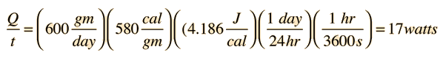
Top of Form
Top of Form
Bottom of Form
As part of the physiological regulation of body temperature, the skin will begin to sweat almost precisely at 37°C and the perspiration will increase rapidly with increasing skin temperature. Guyton reports that a normal maximum perspiration rate is about 1.5 liters/hour, but that after 4 to 6 weeks of acclimatization in a tropical climate, it can reach 3.5 liters/hr! You would have to just sit around drinking constantly, just to keep from getting dehydrated! That maximum rate corresponds to a maximum cooling power of almost 2.4 kilowatts!
Bottom of Form

ELECTRICAL SIGNALLING IN BIOLOGY: BIOSIGNALLING

Electrical signaling is a process in biological systems that involves the generation and use of electrical signals by cells:

Bioelectrical signals -Cells like those in the heart, muscles, and nerves generate electrical signals through ionic processes. These signals are important for information processing in the nervous system and for the mechanical work of the heart and muscles.

Signal transduction -When a receptor detects a specific form of energy or matter, it activates chemical and electrical changes in neurons. These neurons can then communicate with other neurons in the nervous system to coordinate responses.

Cell signaling - Cells respond to electrical, chemical, or mechanical signals, such as hormones, neurotransmitters, ion currents, and mechanical stretch and shear. Cell signaling is important for communication, which governs cell activities and coordinates multiple-cell actions.

Organism-level signaling - Hormones and the nervous system perform signal transmission on the organism level.

Some organisms that don't have nervous systems also exhibit electrical activity. For example, many types of fungi show electrical activity in response to changes in chemicals, light, and environmental stresses.

Electrical signaling is a key part of biological systems, playing a role in information processing, muscle and heart function, and maintaining homeostasis:

Bioelectrical signals - Cells like nerve, heart, and muscle cells generate electrical signals through ionic processes. These signals are important for information processing in the nervous system and for the mechanical work of muscles and the heart.

Signal transduction - A receptor detects matter or energy and activates electrical and chemical changes in neurons. Neurons then communicate with other neurons in the nervous system to coordinate responses.

Organism-level signaling - The nervous system and hormones transmit signals on the organism level.

Electrical activity in fungi - Some organisms without nervous systems, like fungi, also exhibit electrical activity. Fungi can show specific electrical patterns in response to environmental changes like light, chemicals, and stress.

Type of signaling | Description
Direct signaling | Allows a group of cells to coordinate their response to a signal that only one of them may have received.
Endocrine signaling | Uses hormones to communicate, unlike the nervous system, which uses electrical signals.
Neuronal cell signaling | Faster and short term.
Chemical signaling | Slower and long term.
Controlling bioelectric signals could be useful in biomedical and synthetic bioengineering applications. For example, it could be used to induce regeneration, alter regeneration patterns, or overcome defects.

There are several types of biosignals, including:

Electroencephalogram (EEG): Records the electrical activity of the brain
Electrocardiogram (ECG): Records the electrical activity of the heart
Electromyogram (EMG): Monitors the electrical activity of muscle cells
Electrooculogram (EOG): Records the cornea–retina potential difference and observes eye movements
Electroretinogram (ERG): Records the activity of the eye retina
Electrogastrogram (EGG): Records the activity of the gastric muscles
Galvanic skin response (GSR): Also known as electrodermal activity (EDA)

Biosignals are physiological electrical signals emitted by biological beings when they move their eyes, flex a muscle, think, or sleep. They can be measured and recorded using a device called a biotransducer.

Biosignaling in fish: Fish use electrical signals for a variety of purposes, including communication, navigation, and hunting prey:

Electrolocation - Some fish, like the elephantnose fish, use electrolocation to find prey by generating weak electric fields to scan their surroundings. The fish can then use the images formed to determine the shape, size, volume, and material of objects.

Communication - Electric fish use electric organ discharges (EODs) to communicate with other fish. EODs are distinctive to each species, and can also vary based on age, sex, and condition.

Hunting - Some fish, like the electric eel, can produce high-voltage discharges to stun prey or defend themselves.

Electroreception - Many primitive fish orders, as well as some aquatic amphibians, the platypus, and the echidna, can detect low-voltage electrical impulses from other individuals.

Electric fish produce electricity through electrocytes, which are cells that pump out Na+ and K+ ions to create a dipole. The stacking of the electrocytes affects the electricity produced by the fish. For example, the electric eel has many electrocytes in one column, while the electric ray has many shorter columns.

Electric eels are probably the best known electrogenic animals. Electrogenic animals can generate their own electricity. There are also animals that can detect electricity. They are called electroreceptive.
Most electrogenic animals are also electroreceptive. But there are many electroreceptive animals that are not electrogenic. Some electroreceptive animals are echidnas, platypuses, bees, spiders, dolphins, sharks and rays. Some types of bacteria, yeast and fish are also electrogenic.

Electric Fish - Almost 350 species of fish can generate and detect electrical signals. Why so many fish? It can be very dark underwater. Fish can use electricity to communicate and move around in the dark. They can also use it to attack prey.

Scientists classify electric fish into two groups. Weakly electric and strongly electric.

Weakly Electric Fish: Weakly electric fish have electric organs in their tails. This structure can generate up to one volt of electricity. An AA battery generates 1.5 volts of electricity. The electric field produced by electric organs travels about 1 metre around the fish. Weakly electric fish also have special cells in their skin. Electroreceptor cells help the fish sense changes in its own electric field. The fish can sense the size, shape and location of objects through changes in its electric field. It can also sense if there are other, similar fish nearby. This ability is called electrolocation. Weakly electric fish don’t make enough electricity to attack prey. The elephantnose fish is an example of a weakly electric fish.

Strongly Electric Fish: Only a few types of fish are strongly electric. These include electric eels, electric catfishes and electric rays. The elephantnose fish only has one electric organ. But electric eels have three pairs of electric organs! Together these organs make up four-fifths of the eel’s body. Eels generate low-voltage pulses for electrolocation. But they generate high-voltage pulses for hunting and self-defence. These pulses can be up to 860 volts. Electric eels are the most powerful electric fish. Shocks from them can be deadly to humans.

How do these fish generate electricity? The fish’s electric organ is filled with disc-shaped cells. These are called electrocytes. Electrocytes are positively charged on the outside. They are negatively charged on the inside.
But sometimes the fish sends a message from its brain. This signal travels through its nervous system to its electric organ. There, it changes the pattern of electrical charges in the cells. One side of each stack becomes positive. The other side becomes negative. This alternating pattern of charges creates an electrical current. This turns the electrocytes into a living battery! The signals reach the cells at exactly the same time. This turns stacks of electrocytes into a series of batteries. This increases their total voltage.

So why don’t these fish zap themselves? Scientists aren’t really sure why. It may be that the current leaves their bodies too quickly to hurt them. It may be that fish’s electric organs are far away from its other organs. Scientists also think electric fish may have proteins around their electric organs. These could act as insulators.

In 1800, the explorer Alexander von Humboldt witnessed a swarm of electric eels leap out of the water eto defend themselves against oncoming horses. Most people thought the story so unusual that Humboldt made it up.

Electric eels fish using electricity is more common than you might think and yes, electric eels are a type of fish. Underwater, where light is scarce, electrical signals offer ways to communicate,
navigate, and find—plus, in rare cases, stun—prey.

Nearly 350 species of fish have specialized anatomical structures that generate and detect electrical signals. These fish are divided into two groups, depending on how much electricity they produce. Electric organs Scientists call the first group the weakly electric fish. Structures near their tails called electric organs produce up to a volt of electricity, about two-thirds as much as a AA battery.

How does this work? The fish's brain sends a signal through its nervous system to the electric organ, which is filled with stacks of hundreds or thousands of disc-shaped cells called electrocytes. Normally, electrocytes pump out sodium and potassium ions to maintain a positive charge outside and negative charge inside. But when the nerve signal arrives at the electrocyte,
it prompts the ion gates to open. Positively charged ions flow back in. Now, one face of the electrocyte is negatively charged outside and positively charged inside. But the far side has the opposite charge pattern. These alternating charges can drive a current, turning the electrocyte into a biological battery. The key to these fish's powers is that nerve signals are coordinated to arrive at each cell at exactly the same time. That makes the stacks of electrocytes act like thousands of batteries in series. The tiny charges from each one add up to an electrical field that can travel several meters.

Electro receptors Cells are buried in the skin allow the fish to constantly sense this field and the changes to it caused by the surroundings or other fish. The Peter’s elephantnose fish, for example, has an elongated chin called a schnauzenorgan that's riddled in electroreceptors. That allows it to intercept signals from other fish, judge distances, detect the shape and size of nearby objects, and even determine whether a buried insect is dead or alive. But the elephantnose and other weakly electric fish don't produce enough electricity to attack their prey. That ability belongs to the strongly electric fish, of which there are only a handful of species. Electric eel The most powerful strongly electric fish is the electric knife fish, more commonly known as the electric eel. Three electric organs span almost its entire two-meter body.
Like the weakly electric fish, the electric eel uses its signals to navigate and communicate, but it reserves its strongest electric discharges for hunting using a two-phased attack that susses out and then incapacitates its prey.
First, it emits two or three strong pulses, as much as 600 volts. These stimulate the prey's muscles, sending it into spasms and generating waves that reveal its hiding place. Then, a volley of fast, high-voltage discharges causes even more intense muscle contractions. The electric eel can also curl up so that the electric fields generated at each end of the electric organ overlap. The electrical storm eventually exhausts and immobilizes the prey, and the electric eel can swallow its meal alive.

Electric catfish: The other two strongly electric fish are the electric catfish, which can unleash 350 volts with an electric organ that occupies most of its torso, and the electric ray, with kidney-shaped electric organs on either side of its head that produce as much as 220 volts. There is one mystery in the world of electric fish: why don't they electrocute themselves? It may be that the size of strongly electric fish allows them to withstand their own shocks, or that the current passes out of their bodies too quickly. Some scientists think that special proteins may shield the electric organs, but the truth is, this is one mystery science still hasn't illuminated.

Electrical signals in the brain are generated by the cooperative action of brain cells, and are the basis for how neurons communicate with each other:

Action potentials: These are electrical events that carry information from one part of the brain to another. They are generated when a stimulus, like sensory input, causes a rapid change in the electrical charge of a neuron's membrane.

Resting membrane potential: This is a negative potential generated by nerve cells.

Synapses: These are the junctions between two neurons. When an action potential reaches a synapse, the neuron releases a chemical neurotransmitter. This chemical message can either trigger an action potential in the next neuron, or it can quiet the message.

Nerve impulses: These are electrical impulses that flow along the length of a neuron.

Nerve cells generate electrical signals that transmit information. Although neurons are not intrinsically good conductors of electricity, they have evolved elaborate mechanisms for generating electrical signals based on the flow of ions across their plasma membranes.

The heart's electrical system, also known as the cardiac conduction system, controls the heart's rhythm and rate of beating. Electrical signals travel through the heart's conduction pathway, causing the heart to contract and pump blood:
1. Sinoatrial (SA) node
The heart's natural pacemaker, located in the right atrium, generates an electrical signal.
2. Atria
The electrical signal travels through the atria, causing them to contract and pump blood into the ventricles.
3. Atrioventricular (AV) node
The signal slows down in the AV node, which is located between the atria and the ventricles. This allows the ventricles to finish filling with blood.
4. Ventricles
The AV node fires another signal that travels to the ventricles, causing them to contract and pump blood out of the heart.

The heart's electrical system is responsible for keeping the heart pumping blood to the body and lungs. The heart rate changes in response to the body's needs. For example, the heart rate increases during exercise to deliver more oxygen to the body. During rest or sleep, when the body needs less oxygen, the heart rate decreases.

Problems with the heart's electrical system can cause symptoms like: Lightheadedness or fainting, Palpitations, Shortness of breath, and Chest pain or discomfort.

A doctor can use an electrocardiogram (ECG) to assess the heart's rhythm. If the rhythm is abnormal, the doctor may recommend medicine or a procedure.

The heart's pacemaker sends out an electrical signal (impulse) that spreads throughout the heart along electrical pathways. These pathways transmit the signal from the upper to the lower chambers of the heart, which causes the heart muscle to contract.

Electrical signals in plants are a way for plants to communicate and adapt to environmental changes:

How they work
Electrical signals in plants are caused by a difference in voltage between the inside and outside of a cell. This difference occurs when ions, or electrically charged atoms, move in and out of the cell. When a signal is triggered, ions flow quickly through the cell membrane, creating a rapid change in voltage that propagates as an impulse.

Types of electrical signals: There are three types of electrical signals in plants:

Local electrical potential (LEP): A sub-threshold response caused by environmental changes like light, water, soil, air temperature, and humidity
Action potential (AP): A widespread signaling phenomenon that can quickly transmit information over long distances. APs are caused by non-damaging stimuli like cold, mechanical, and electrical stimuli
Variation potential (VP): Caused by damaging stimuli like cutting and burning. Unlike APs, VPs decrease in magnitude as they spread away from the stimulated site

How they are generated? Electrical signals are generated in response to stimuli like light, temperature, wounding, salt stress, and gravitropic stimulation. The signals are propagated through cells in the cortex by plasmodesmata, and then reach the sieve tube of the phloem, where they can be transmitted throughout the plant

How they are used? Electrical signals help plants convey information, prompt movement, and even count. They are a key part of the plant's ability to adapt to changing environmental conditions.

However, it is well-known that plants have the ability to generate different types of long-range electrical signals in response to different stimuli such as light, temperature variations, wounding, salt stress, or gravitropic stimulation.

